Solubility-Based Methods

1. Extraction
   1. Combines **two immiscible liquids**, one of which easily dissolves the compound of interest
   2. Polar (water) layer = aqueous phase
      1. Dissolves compounds with HB or polarity
   3. Non-polar layer = organic phase
      1. Dissolves non-polar compounds
   4. Extraction is carried out in a separatory funnel. One phase is collected, and the solvent is then evaporated using a rotary evaporator (rotovap)
   5. Acid-base properties can be used to increase solubility
      1. HA + Base → A- + HB+
      2. Anion dissolves more readily in the polar layer
2. Wash
   1. The reverse of extraction
   2. A small amount of **solute that dissolves impurities** is run over the compound of interest
3. Filtration
   1. Isolates a **solid (residue) from a liquid (filtrate)**
   2. Two types:
      1. Gravity filtration
         1. Used when the **product of interest is in the filtrate**
         2. Hot solvent is used to maintain solubility
      2. Vacuum filtration
         1. Used when the **product of interest is the solid**
         2. A vacuum is connected to the flask to pull the solvent through more quickly
4. Recrystallization
   1. Method for **further purifying crystals** in solution
   2. Dissolve the product in a minimum amount of hot solvent and let it recrystallize as it cools
      1. Solvent chosen should be the one in which the product is soluble only at high temperatures
      2. Hence, when the solution cools, only the desired product will recrystallize out of solution, excluding the impurities

Distillation

* Separates **miscible liquids** according to **differences in their boiling points**
* The liquid with the lowest boiling point vaporizes first and is collected as the distillate

1. Simple distillation
   1. Boiling points are under 1500C and are at least 250C apart
2. Vacuum distillation
   1. Boiling points are over 1500C to prevent degradation of the product
   2. Decreased ambient pressure will allow them to boil at a lower temperature
3. Fractional distillation
   1. Boiling points are less than 250C apart because it allows more refined separation of liquids by boiling point
   2. Increased surface area in the distillation column so that the distillate has more places to condense on its way up the column

Chromatography

* Uses two phases to separate compounds based on **physical or chemical properties**
  + The stationary phase (or adsorbent) is usually a polar solvent
  + The mobile phase runs through the stationary phase and is usually a liquid or gas. This elutes the sample through the stationary phase

1. Thin-layer and paper chromatography (TLC)
   1. Used to identify a sample
   2. Two phases:
      1. Stationary phase = **polar** e.g. silica (usually), alumina, or paper
      2. Mobile phase = **nonpolar** e.g. organic solvent which climbs the card through capillary action
   3. Thus, the more nonpolar the sample is, the further up the plate it will move (with the non-polar mobile phase)
   4. Rf (retardation factor) formula
      1. Remains constant for a particular compound in a given solvent

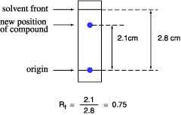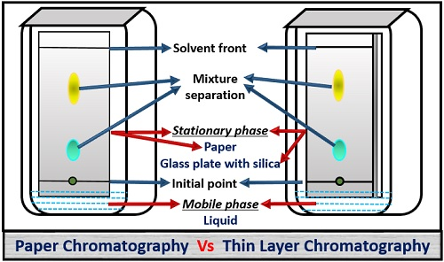

* 1. Reverse-phase chromatography uses a nonpolar card with a polar solvent

1. Column chromatography
   1. Uses polarity, size, or affinity to separate compounds based on their physical or chemical properties
   2. Stationary phase = column containing silica or alumina beads (**polar**)
   3. Mobile phase = **nonpolar** solvent which travels through the column by **gravity**
   4. Three types:
      1. Ion-exchange chromatography
         1. The beads are coated with charged substances to bind compounds with opposite charge
      2. Size-exclusion chromatography
         1. The beads have small pores which trap smaller compounds and allow larger compounds to travel through faster
      3. Affinity chromatography
         1. Column is made to have high affinity for a compound by coating the beads with a receptor or antibody to the compounds
2. Gas chromatography
   1. Separates **vaporizable compounds** according to how well they adhere to the adsorbent in the column
   2. Stationary phase = a coil of crushed metal or polymer
   3. Mobile phase = nonreactive gas
   4. May be combined in sequence with **mass spectrometry**, which ionizes and fragments molecules and passes these fragments through a magnetic field to determine molecular weight or structure
3. High-performance liquid chromatography (HPLC)
   1. Similar to column chromatography, but uses a sophisticated computer-mediated solvent and temperature gradients
   2. Used if the sample size is small or if forces such as capillary action will affect results